

ITA0330-Mobile Computing

Name: T. Dharani Devi Reg no:192425036

Slot: D Course Name: Mobile Computing

Experiment 7: Cellular System Performance Dashboard
Aim: To develop a dashboard prototype displaying the performance criteria of a cellular system.
Procedure:
- Open Figma and create a new design file.
- Create a frame for the network performance dashboard.
- Add metric cards for signal strength and network availability.
- Include bandwidth, latency, and throughput indicators.
- Add charts to represent call drop rates and network performance.
- Apply suitable colors, labels, and status indicators.
- Arrange all elements clearly and preview the dashboard in Prototype mode.

Output:

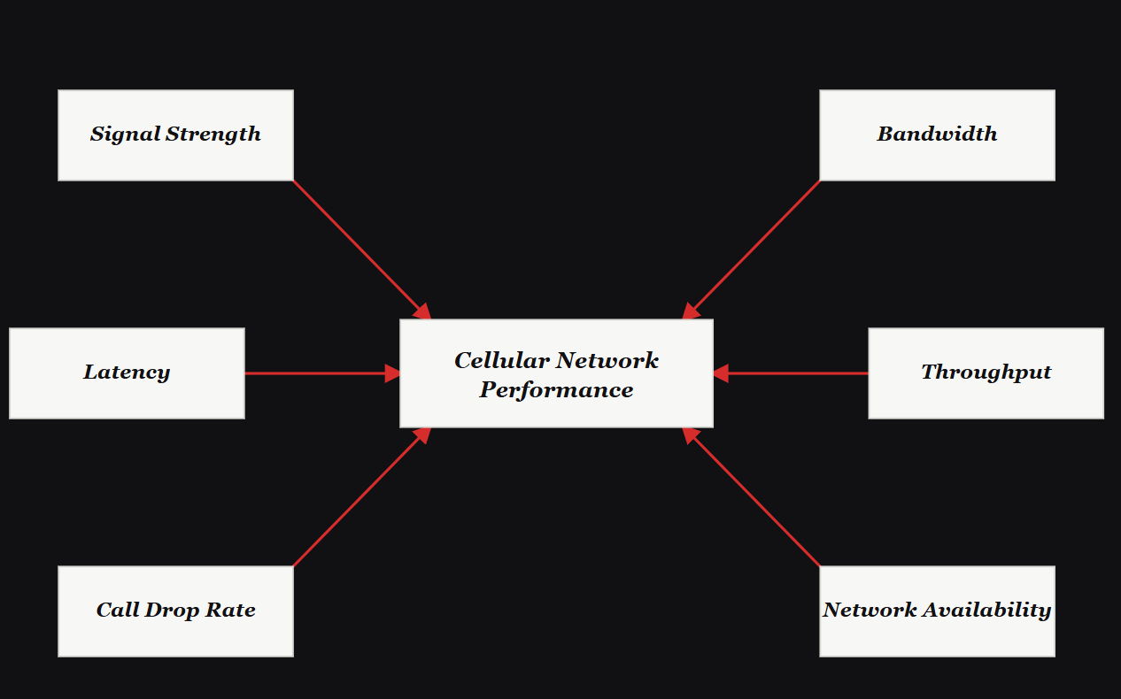
https://www.figma.com/make/wrLqj9pxnTVG6PfR2ITMQ5/EXPERIMENT-7?t=q4ehJPQngmonsvrw-0
Result: Thus, a cellular system performance dashboard displaying important network parameters was designed successfully.

